MACH4METAL

metalworking machinery
Transito 21, 6909 DA Babberich, Netherlands
Tel. + 31 (0)316 – 247123
Fax. + 31 (0)316 - 247956
info@mach4metal.com
www.mach4metal.com
Bank No : 66.52.13.883
IBAN : NL33 INGB 0665 2138 83
BIC : INGBNL2A
VAT : NL 815393635B01

MAZAK NEXUS 250 - II

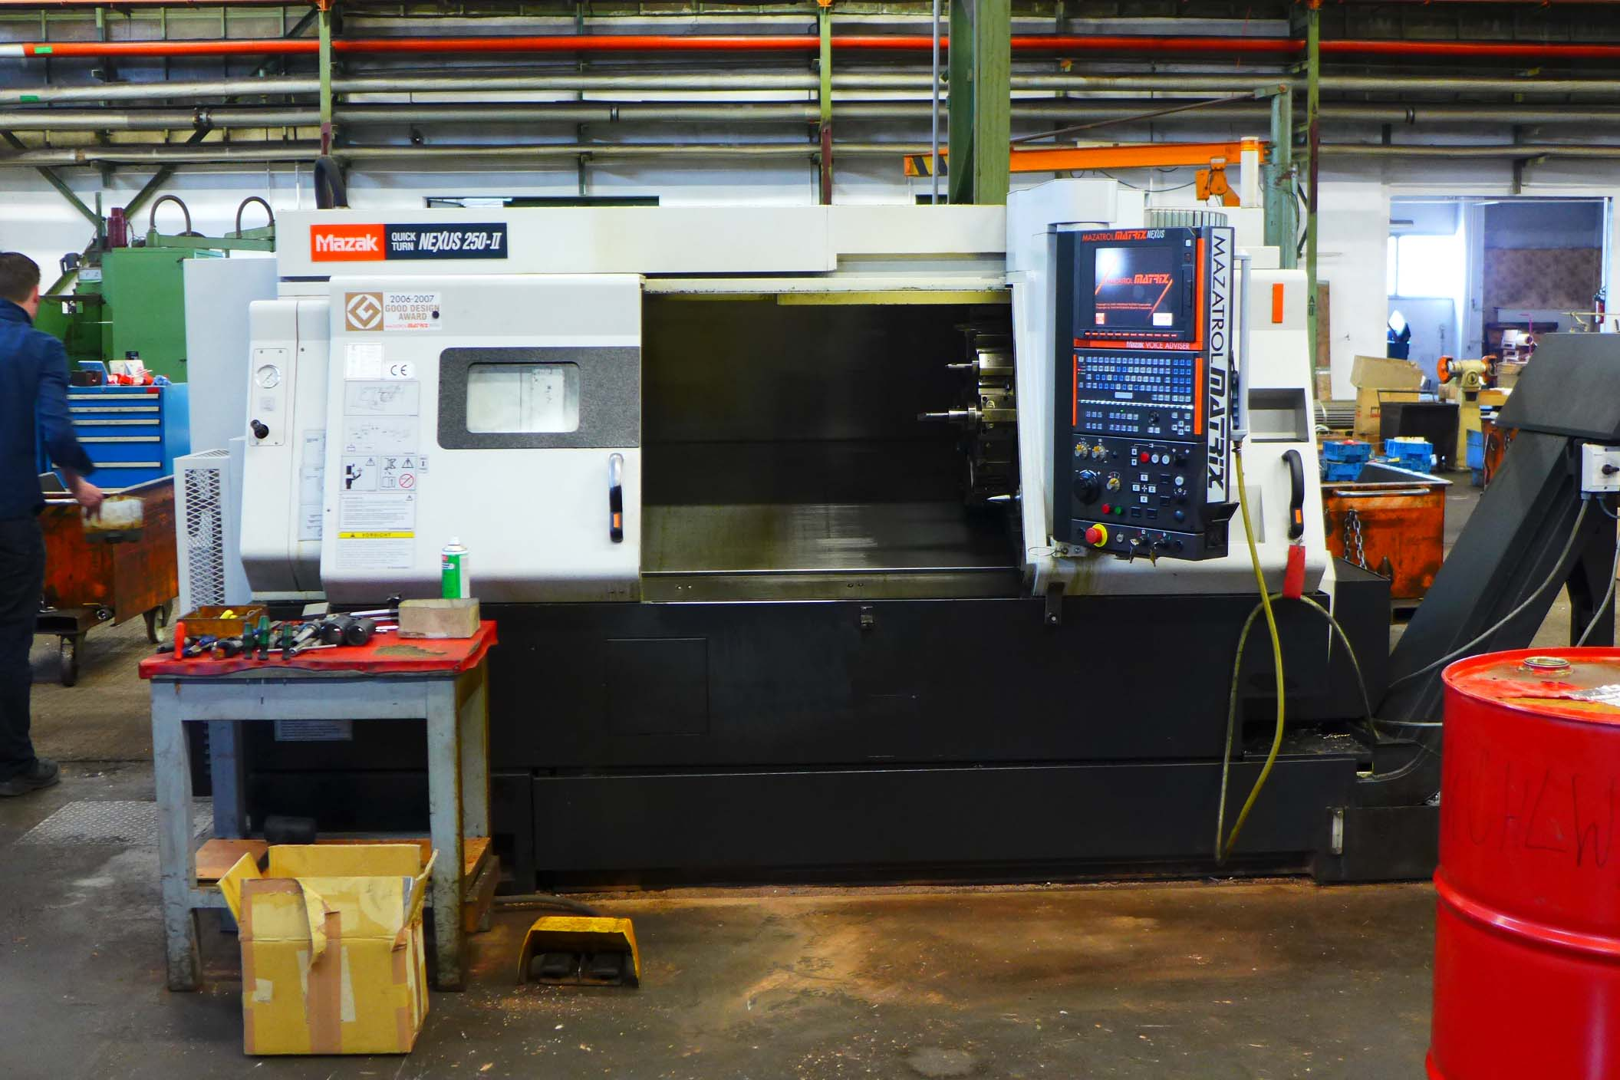
- Make : MAZAK
- Type : QT NEXUS 250 - II
- Serial NO : 205 720
- Age : 2008

- Capacity
- Max. swing Ø : 610
- Max. swing carriage Ø : 350
- DBC turning length : 985
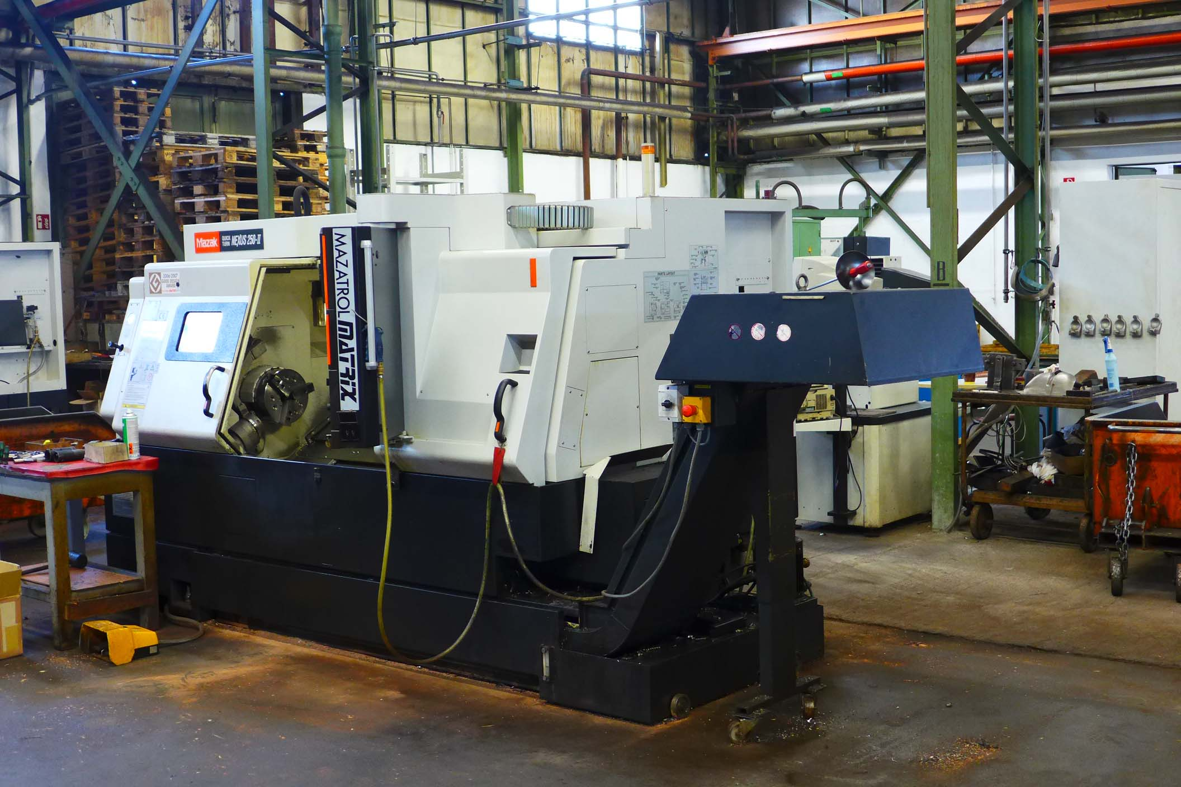
- Spindle bore : 77
- X travel : 190
- Z travel : 1.025
- Spindle speed : 5.000

- Rapid feed X : 30.000
- Rapid feed Z : 33.000

- Tailstock : Mk 4
- Revolver : 12 Positions
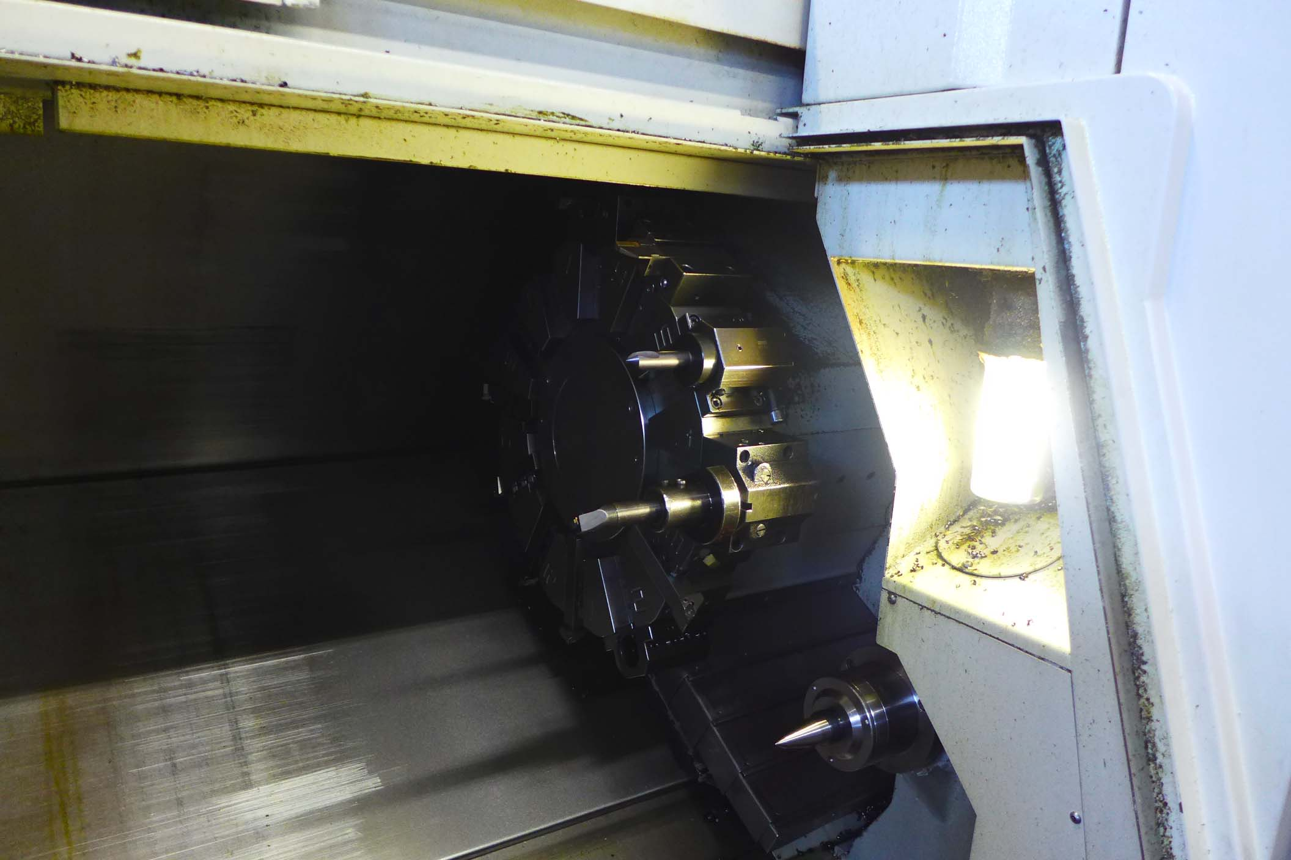

- Dimensions
- Length : 5.200
- Width : 2.500
- Height : 2.300
- Weight : 5.200

- Control MAZATROL MATRIX NEXUS
- Software MATRIC CAMWARE T

- Large tooling package ( EUR 20 K)
- Mayfran chip conveyor UNi 1000
- High pressure coolant 1.1 kW
- Kitagawa B 210 chuck with jaws

Please Note: The above information has been obtained to the best of our ability and belief from, and from the manufacturers where possible. It is given in good faith, but its accuracy can not be guaranteed. Accordingly, it will not form a representation or constitute contractual terms. We advise you to check any vital details!
